# 

# ENIGMA LOCKER

Folder Locker and File Encryptor

### USER MANUAL

# Overview

### What is ENIGMA LOCKER?

### How to install?

### How to use?

### Folder lock

### File locker

### High security

### Creat and get started

### Password bank

### Change password

## What is ‘ENIGMA LOCKER’?

ENIGMA LOCKER is a software which we can use to secure our files and folders . We use this software to lock files and folders.

## How to Install?

To use this software first we need to install the softwere .

The steps are shown below:

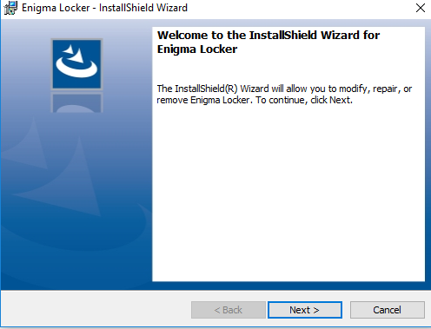

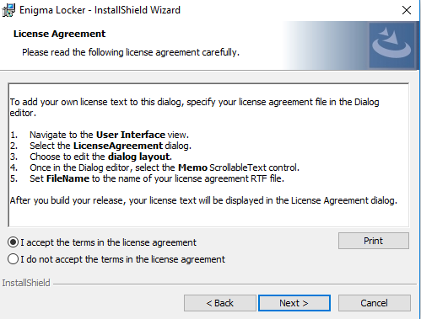

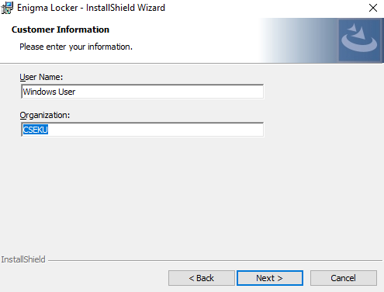

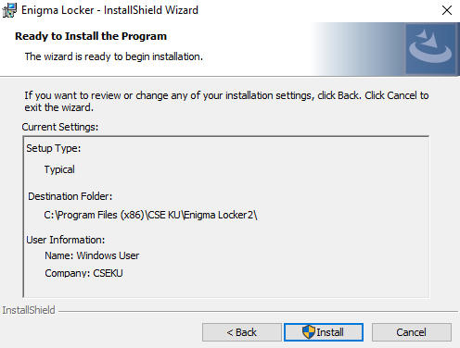

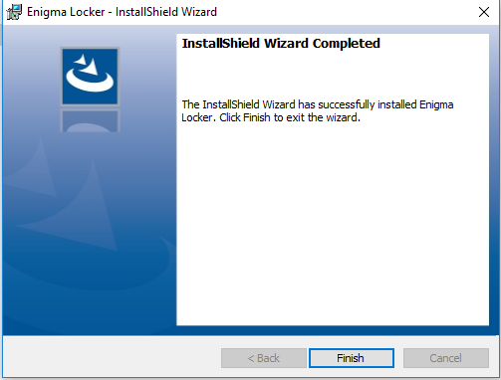

## **Important: There is a .dll file with the package. It need to be addes in the program file.

## How to use?

First we need to create a profile.

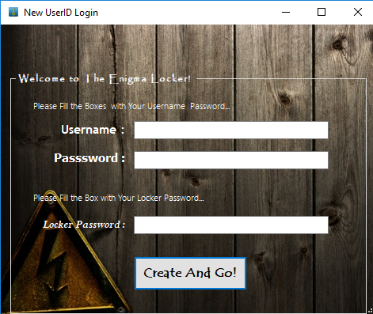

After creating a profile properly we can use the software.

After creating profile we can see this page

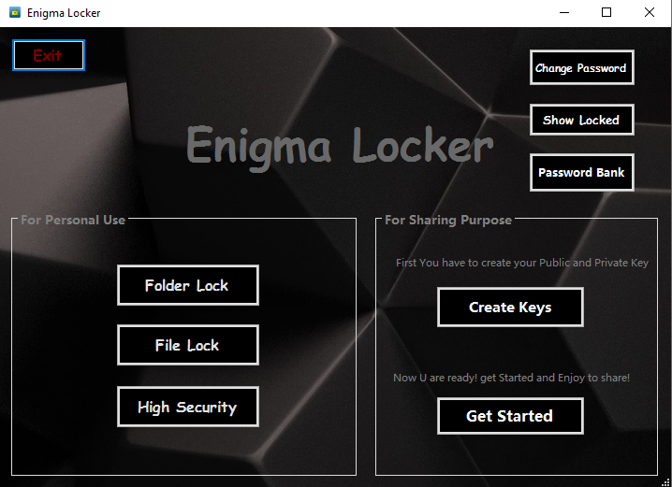

Here we can see different features. The features are discussed below:

### Folder lock :

Folder lock is used to lock only a folder . We have to browse the folder we want to lock and give our password. Then we have to click the lock button. Thus the folder will be locked.

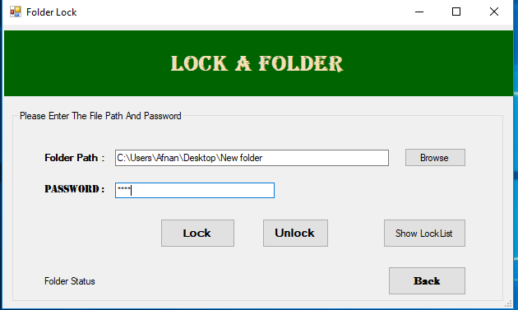

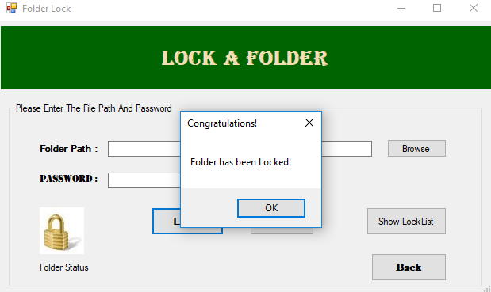

To unlock a locked folder we have to select the locked folder we want to unlock and click unlock button.

### File Locker :

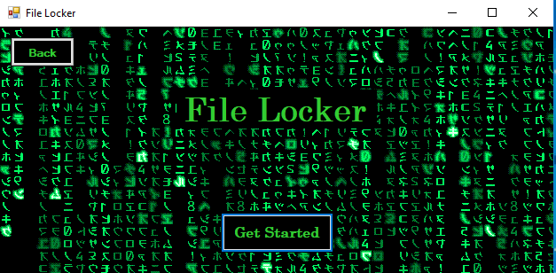

Let’s get started…..

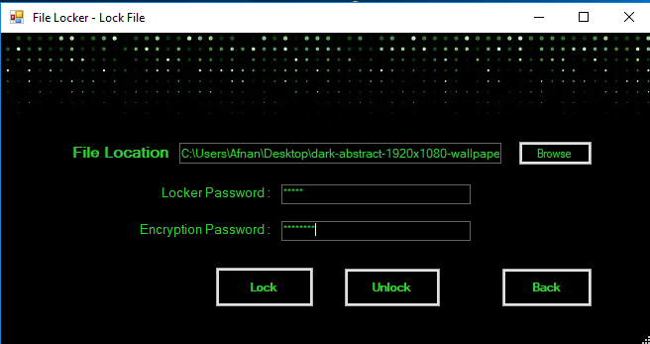

Like folder locker we have to browsethe file and give password. But in this feature we have to give an ENCRYPTION PASSWORD which will be our encryption key. The encryption key must be of 8 digits.

Then we have to click the lock button to encrypt the folder.

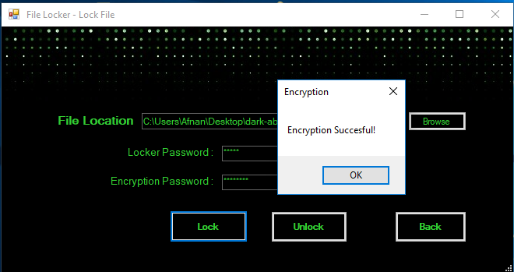

Again if we want to decrypt the file we have to give the file location,password and key again to decrypt the file.

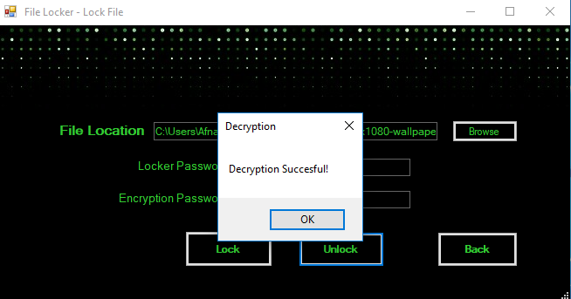

### High security:

High security can perform both folder lock and file encryption. To do so,we have to give file location ,password and encryption key. Then we can get aor full folder encrypted and locked.

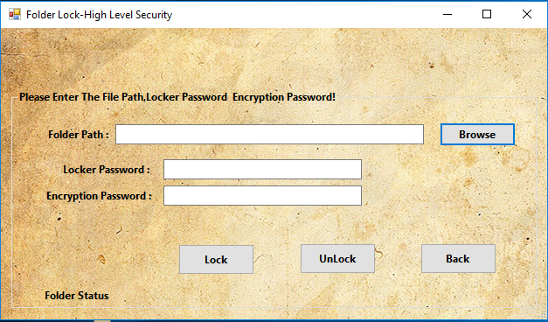

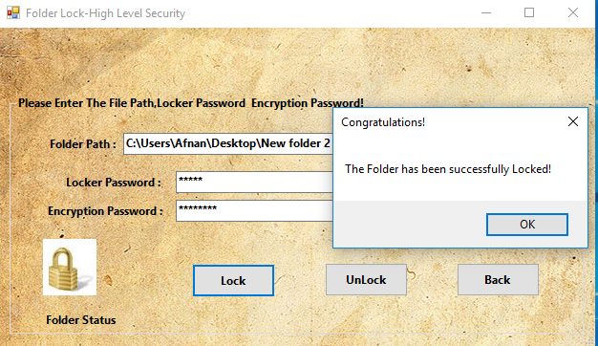

To decrypt the file,we have to give file locaton,password and key again and click unlock.

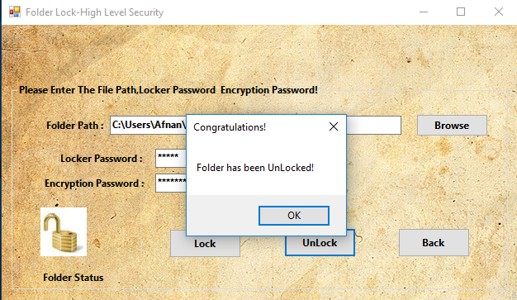

## Create key & Get Started:

These features are used to transfer encrypted file . To do so, we have to create a private and public key first.

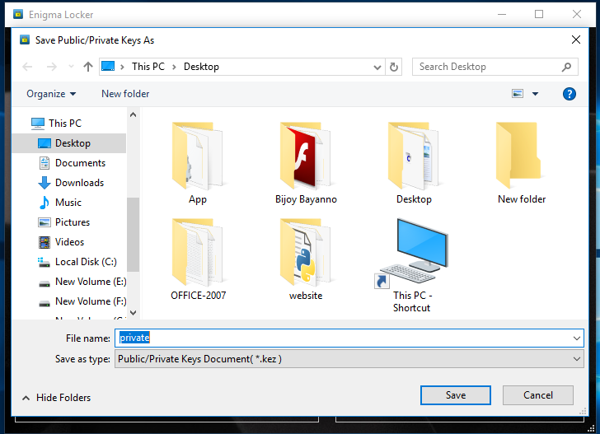

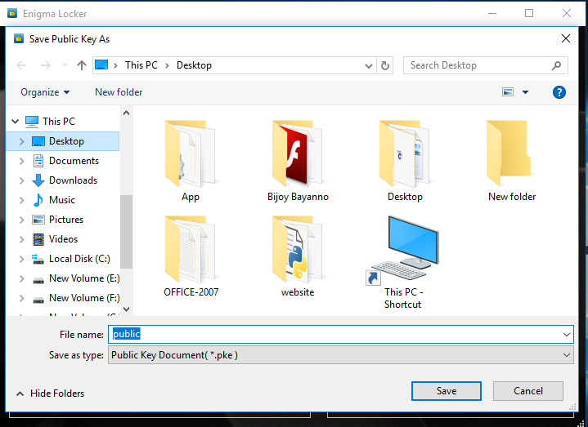

Then we have to go to GET STARTED and import public key to import the encryption key, then import the file we want to encrypt….

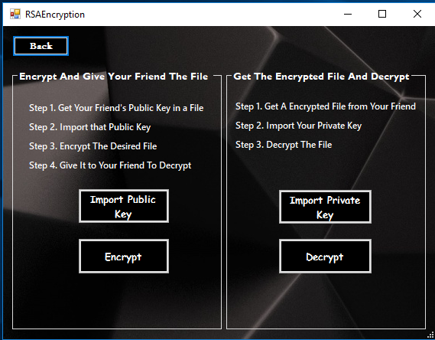

And to decrypt file we have to import private key and file again.

### Password Bank:

Password bank is a place where all the passwords are kept. To access the password bank we have to give our master password first.

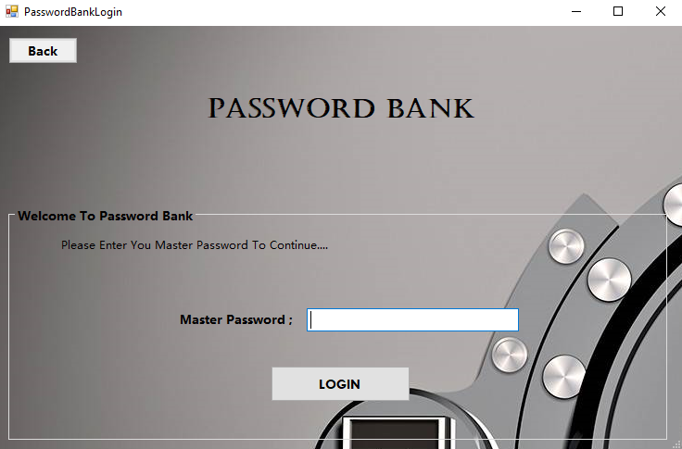

Then we can see this page.

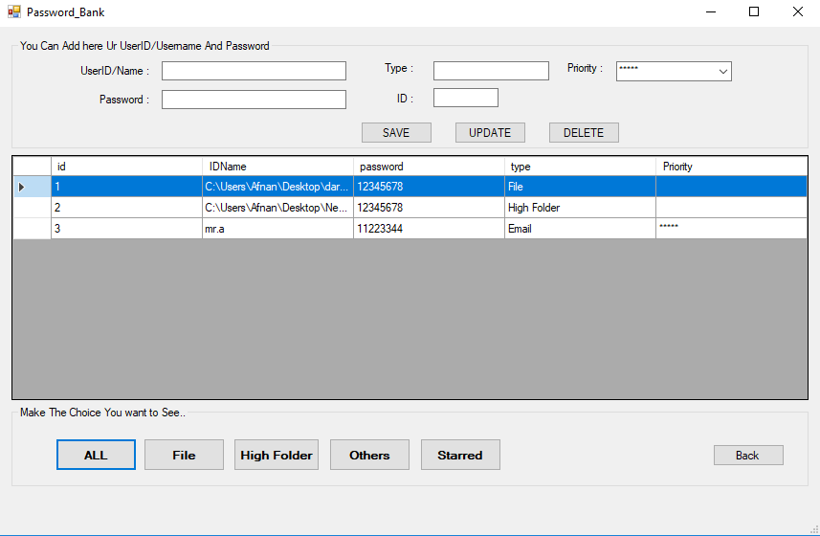

All is to show all passwords

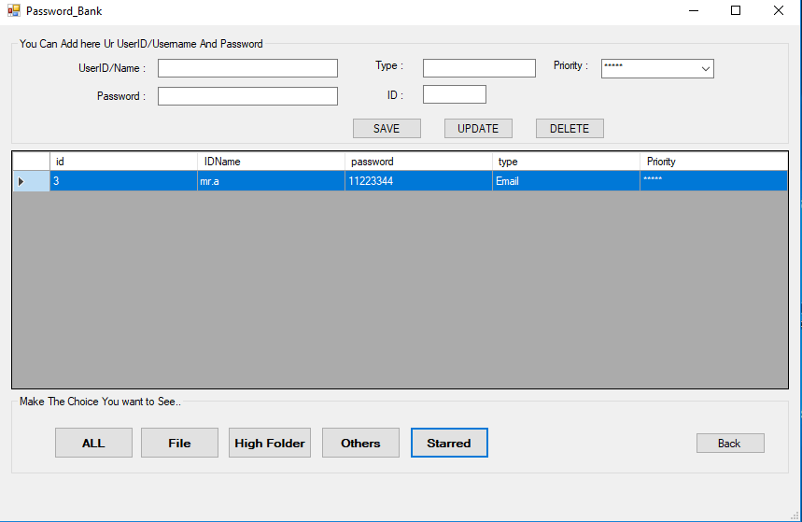

Starred is for the starred passwords.

## Change password :

If we want to change our password. We use this.

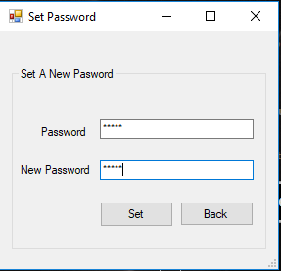

That’s all for now…

Thank you..